Implementing QoS capabilities in IPv6 networks and comparison
with MPLS and RSVP
El-Bahlul Fgee¹, William J. Phillips¹, William Robertson¹ and Shyamala C. Sivakumar² Dalhousie University, Department of Engineering Mathematics ²Saint Mary s University, Faculty of Commerce 1340 Barrington Street, Halifax, Nova Scotia B3J 2 4 Phone Number (902) 422-8393, Fax Number (902) 423-1801 Email fgeeee@.is2.dal.ca
Abstract
With the growth of the Internet and Intranets, and the use of multimedia applications, video and audio streams, QoS (Quality of Service) technology has become more relevant and important [I]. The next generation Internet Protocol (IPv6) provides more features than IPv4 such as more address space and new fields that can be used to enhance and make the usage of IP networks more frequent even with sensitive traffic flows. Current IP networks provide best effort traffic delivery since no QoS features were implemented so other protocols are used to guarantee requests for sensitive traffic flows. IPv6 has implemented two fields that can be used as tools to implement QoS, the two fields are, Flow label and Traffic class. Flow label is a 20 bit field used by a source to label sequences of packets for which it requests special handling by IPv6 routers. Traffic class is used to indicate the priority level of the traffic flow. IPv6 routers will look at the flow label field plus source address to process the flow packets PI
In this paper, we will investigate IPv6 based end-to-end QoS methodology on Quality of Service parameters such as end-to-end delay, packet loss and throughput delay using simulations performed with Network Simulator (NS)[3J. The results obtained wilt be compared with two traditional end-to-end Quality of Service methods, viz., MPLS (Multi Protocol Label Switching) and RSVP (Resource Reservation Protocol).
Keywords: QoS, IPv6, Flow label, Traffic Class
1. INTRODUCTION
As we know QoS, is a set of technologies that enables network administrators to optimally use network resources. It is also a measurement of how
CCECE 2003 CCGEI 2003, Montre al, May/Mai 2003 O-7803-7781-8/03/S17.00 © IEEE the network is responding to user demands. There are three parameters commonly used to measure QoS and they are [4][5]:-
1 - End-to end transient delay which is the elapsed time for a packet to be passed from the source through the network to the receiver.
2- Packet loss, the number of packets dropped during the transmission,
3- Link utilization, the maximum data transfer rate that can be sustained between two end points.
IPv6 has been invented to solve some of the outstanding IPv4 problems such as lack of QoS support, security, fragmentation and reassembling and limited number of hops that can be connected into a subnet. In this paper we wilt study the enhancement made to make the IP layer support QoS. The introduction of the flow label as we mentioned allows the user to set this field if the traffic it is generating needs special treatment by the nodes through which it travels.
We will build a network using NS and test the performance of the QoS parameters then compare them to the other two QoS mechanisms, RSVP and MPLS. RSVP reserves resources for each traffic flow by using a signaling algorithm to set up a path between a sender and a receiver. MPLS uses labels to switch traffic inside a network that supports MPLS. In the other sections, we will outline the features of IPv6, RSVP and MPLS and then present the simulation results and end up with the conclusions.
2. IPv6 QoS Features
The flow label we mentioned can be used as an identifier since flow labels generated by the same source are unique use of the combination of the flow label plus the source address allows the routers to process the packets without looking at the other fields. Also flow label routing resolves the implicit layer Violation problem in which a router needs to access the transport or application protocol to process packets instead of just using the data at the network
layer. The other benefits gained from using flow labels are [6]:-
1- Decreases the average processing load of the network which reduces the end-to-end delay as seen from this equation [7]
_{t} -k + L«2L + T
Where — is the stream processing rate, (/ C)
is the queuing delay and T_{r} is the processing time with a router. Therefore as T_{r} gets small, the end-to-end delays decreases.
2- Flow label usage facilitates end-to-end IP-level security mechanisms since packet classification does not rely on higher level information.
3- All information needed to uniquely classify packets is available in the IPv6 header.
The other field that will be used to achieve good QoS is Traffic Class which is an 8 bits field intended to identify different traffic or priority classes of passing packets.
These two fields will be used to implement QoS in IPv6 networks in which priority bits will be set for real time traffic and a flow label will be given to this stream.
3. Resource Reservation Protocol (RSVP)
RSVP is a network control protocol that enables Internet applications to obtain guaranteed quality of service (QoS) for their data flows. RSVP causes routers to reserve resources, if available, when they receive requests from hosts. These requests have to be checked by each router management system, RSVP process, policy control and admission control, to check resources availability. Routers that accept these requests are called soft states and are they kept alive by sending refreshing messages. RSVP can dynamically change the QoS parameters at any time without tearing down the connection [8]. The two fundamental message types in RSVP are the Resv (reservation) message and the Path message [5]. The Resvs are generated by receivers to create and maintain the reservation state in each node along the path and they contain information about the reservation style, Flow Spec used to set a node s packet scheduling process parameters, and Fitter Spec which is used to set node s packet classifier process. The Path messages store path information, previous Hop IP address, and parameters that describe the sender s traffic, such as the sender traffic flow, that help identify the sender s flow from others. Figure 1 shows the reservation procedure.
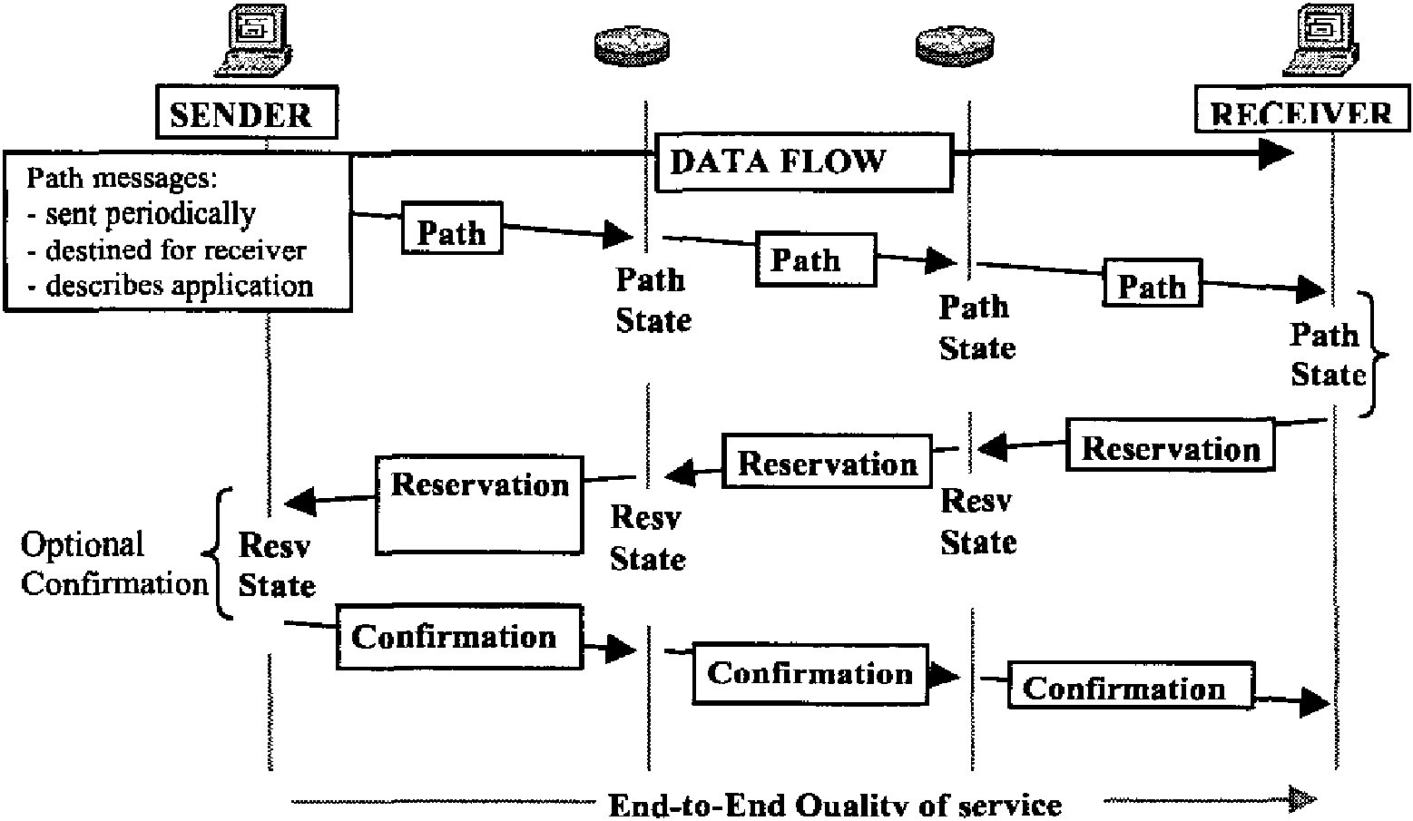
Figure 1 - RSVP path and reservation messages setup
4. Multi Protocol Label Switching MPLS) MPLS is a forwarding scheme in which a short fixed
length ' label acts as a shorthand representation of an IP packet s header. Incoming packets are assigned
these labels at the ingress of an MPLS-capable domain. Subsequent classification, forwarding and service for packets traveling through MPLS network are based on these labels. Ingress label routers classify traffic flows into FECs (forwarding equivalent classes) that are defined based on any of the IP header fields, such as TOS, source port, and destination port [5] [9]. Labels are then assigned to traffic flows using FECs to map IP addresses to labels. These labels guide the routers on how to treat incoming packets regarding both the route to follow and the type of service. MPLS Figure-2 shows FEC assignments at the Ingress and Egress routers and label swapping inside the MPLS domain.
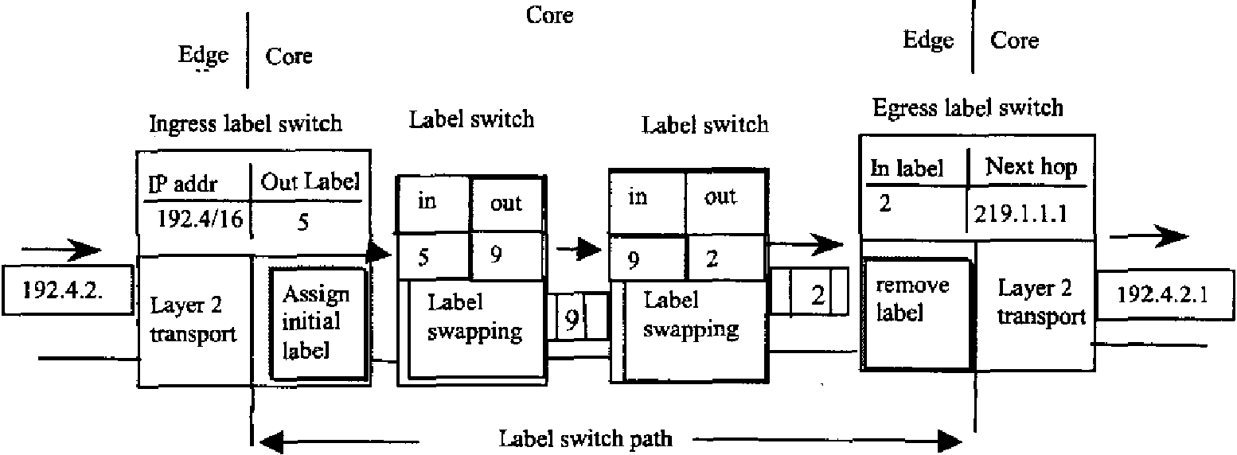
Figure 2 - Routing MPLS Domains.
5. Simulation and Results
5.1 Simulation
In the simulation, we used NS to simulate four scenarios to test QoS on a network. Two of the scenarios, RSVP and MPLS, are commonly used in the literature. The other two implement flow labels in an IP network and use either weighted fair queuing (WFQ) or class based queuing (CBQ) to guarantee that packets with high priority are processed first as each scheme uses different method to process these packets [5]. The network has nine nodes, one sending node (nO), two receiving nodes (n7, n8) and the others are used as backbone nodes. The sending node generates four traffic flows, two for each receiving node. One of each pair is high priority traffic flow. 80% of the total load was assigned for these traffics when WFQ and CBQ were tested. Also, the same traffic flows have guaranteed reservation when RSVP is used. In MPLS, the backbone nodes support MPLS but nl and n6 are used as Ingress and Egress end points, and nO, n7 and n8 do not support MPLS. The traffic generation rate was 500 Kbps, packet size is 500 bits and all links are 1Mbps and 10 ms except nO and nl which were 1.5 Mbps since the four flows has to pass through at the same time.
5.2 Results
In this paper, the following performance parameters are measured and compared:
a) End-to-end delay from the sending to the receiving nodes.
b) Percentage of traffic lost is calculated from the traffic sent and the traffic received.
c) Throughput.
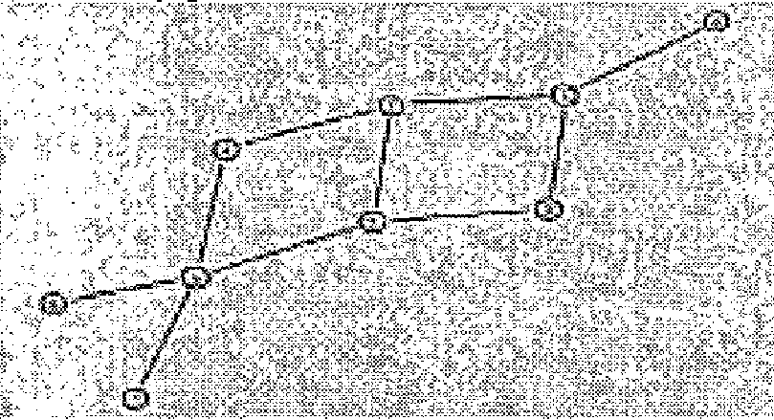
Figure 3 Simulation Network Topology Table 1 - End-to-end delay comparison
Traffic | IPV6 | IPV6 | RSVP | MPLS
flow | with | with
 | WFQ | CBQ
Flow 1 | 1.185 s | 0.261s | 0.096 s | 0.123 s
Flow 2 | 0.265 s | 0.073 s | 0.094 s | 0.125 s
Flow 3 | 0.269 s | 0.077 s | 0.325 s | 0.125 s
Flow 4 | 1.181 s | 0.069 s | 0.069 s | 0.099 s
Table 2- Packet loss rate
Traffic | IPV6 | IPV6 | RSVP | MPLS
flow | with | with
 | WFQ | CBQ
Flow 1 | 79% | 99% | 5% | 20%
Flow 2 | 20% | 0% | 0% | 4%
Flow 3 | 20% | 0% | 1% | 4%
Flow 4 | 73% | 91% | 90% | 96%
Table 3- Traffic Throughput (Mbits/sec)
Traffic | IPV6 | IPV6 | RSVP | MPLS
flow | with | with
 | WFQ | CBQ
Flow 1 | 0.15 | 0.01 | 0.45 | 0.25
Flow 2 | 0.4 | 0.50 | 0.50 | 0.5
Flow 3 | 0.4 | 0.50 | 0.5 | 0.5
Flow 4 | 0.16 | 0.02 | 0.02 | 0.01
Note, in the previous tables flows 2 and 4 are assigned the highest priority when WFQ, CBQ and MPLS are used.
5.3 Results Analysis
From previous tables, we can observe:
1- IPv6 using CBQ scheme gives the lowest delay for the two high priority flows since they are processed first. The other two have higher delay and higher loss rate. Also flows 2 and 3 have the highest utilization.
2- RSVP gives low delay since paths are reserved and packets without reservation are dropped at the source if no resources are left for them. Flows 2 and 3 have the highest utilization but lowest drop rate and delay.
3- MPLS using CBQ gives lower delay lower loss rate for flow 2 and 3 since they were assigned 0.8 of the bandwidth. Also end-to-end delay is higher than CBQ and RSVP because packets at the ingress points are processed and new flow Ids are assigned taking more time and increasing the delay.
4- IPv6 using WFQ gives higher delay and higher drop rate since this queuing scheme allows all packets with different priorities to be processed. However, CBQ allocates dedicated portions of bandwidth to higher priority packets [4].
Note, building a network using NS does not allow us to measure real processing time and the user has to setup RSVP reservation time and MPLS LSP (label switching paths). Therefore, the end-to-end delay does not include this time nor the router processing time which add to the total delay as previously mentioned. NS measures the difference between the arrival time and the actual sending time (no routing and setup time).
6. Conclusion
For traffic flows with the highest QoS ratings, RSVP and IPv6 using CBQ and MPLS give low traffic loss and high throughput However, CBQ gives the lowest delay for both high QoS rating traffic flows. MPLS gives higher end-to-end delay for traffic flows 2 and 3 since ingress points add more processing time. RSVP setup procedures take time since path messages and reservation messages have to travel from sender to receiver across all nodes. Also each node has to implement its own QoS management in which decisions have to be made for that node when requests are received. Nodes also have to cache all the reservation information flows thus adding more information to the router tables. Using MPLS QoS methodology, all the backbone nodes have to support MPLS protocols such as LDP (label distribution protocol). Decisions are made in the ingress node which replace IP addresses with labels, however once packets enter the MPLS network they are processed quickly because only the MPLS labels are used. The IPv6 flow label feature takes the advantage of the MPLS label and uses the IPv6 flow label field to process packets thus minimizing lookup (long match up method) time in routers. In the case of special QoS requirements use of the class of service field provides more choices than the type of service field in IPv4.
References
[1] Yoram Bernet, 'The Complementary Roles of RSVP and Differentiated Services in the Full-Service QoS Network", IEEE Communication Magazine, Feb. 2000.
[2] Silvia Hagen, IPv6 Essentials, 0,Reilly Associates, 2002.
[3] The Network Simulator ns-2, http://www.isi.edu/nsnam/ns/, June 2002. [4] Faul Ferguson and Geoff Huston, Quality of Service: Delivering QoS on the Internet and in Corporate Networks. John Wiley Sons, Inc., 1998. [5] Sanjay Jha and Mahbub Hassen, Engineering Internet QoS, Artech House Inc., 2002 [6] Stefan Schmid, Andrew Scott, David Hutchion and K. Froitzheim, QoS based Real Time Audio Streaming on IPv6 Networks",
hnt>://wftw.comp.Iancs.ac.uk/computing,''uscrs/sschm id/Spie/paper.html, 1999.
[7] A. Parekh and R. Gallager, " A Generalized processor sharing approach to flow control in Integrated service networks:The multiple node case" , IEEE 1994.
[8] R.Braden, L. Zhang et al., " Resource Reservation Protocol (RSVP) Version 1 Functional Specification" ,RFC2205, Sep. 1997. [9] Callon, R. et al. " A frame work for Multiprotocol Label Switching", Internet Draft, draft-ietf-mpls-framework-05.txt, Sep. 1999.

